

**Employee Attendance System**

**Outline:**

1. Functional Requirements
2. Non-Functional requirements
3. Technical Specifications
4. Diagrams

4.1 Use-case Diagram

4.2 Activity Diagram

4.3 Data flow diagram

**I. Functional Requirements (What the system *will do*)**

* **A. Employee Management ( Manager module):**
* Manage will be able to:
  1. Add new employees
     + Name
     + ID
     + Department
     + Designation
     + Contact information
     + Job timing).
  2. Update employee information (All above).
  3. Deactivate/terminate employee accounts.
  4. Search employee records.
  5. Generate reports of employees.
* **B. Attendance Tracking:**
  1. Record employee clock-in/clock-out times and take picture at that moment.
  2. Automatic calculation of working hours.
  3. Support for different attendance types (present, absent, late, early departure, half-day, holiday, leave).
  4. Employee will be able to request and approve/reject attendance adjustments (e.g., missed clock-out).
  5. Real-time attendance dashboard for managers.
* **C. Leave Management:**
  1. Employee requests for different types of leave (sick leave, vacation, personal leave. **When on leave, provide leave reason. If sick, provide doctor document**).
  2. Leave approval/rejection (by manager/HR).
  3. Leave calendar/schedule view for employees and managers.
* **D. Reporting ( Manager module):**
  1. Generate attendance reports (monthly)
  2. Export reports in various formats (CSV, Excel, PDF).
* **E. User Roles and Permissions:**
  1. Different user roles (employee, manager, and administrator) will be available.
  2. Role-based access control to different features and data.
  3. Manager will have permissions of:
     + Add new employee
     + Update data of employee and his own profile.
     + Terminate employee and remove his/ her data.
  4. Employee will have permissions of:
     + Login
     + Mark his/ her attendance as:
       - Present
       - On Leave
       - Absent (Automatically save if not present marked )
     + View attendance.
     + Update his / her contact information.
  5. Admin will have all access of data of employees and manager to view it and update it.
  6. All users including employees, manager and admin will login by providing:
     + Id
     + Password

Initially all these id and passwords of employees will be provided by admin.

**Control panel:**

Company will have a control panel in which after login, membership would be issued to the clients and they can use the system according to the package and.

Packages:

For a company whose 20 persons will use this system, will pay

**2. Non-Functional requirements**

**A. Performance:**

1. Fast loading times.
2. Responsive user interface.

**B. Security:**

1. Secure user authentication and authorization.
2. Data encryption method use for passwords storing.

**3. Technical Specifications**

It will be a website based system using following technologies:

1. Frontend: HTML , CSS , JS
2. Backend : PHP
3. Hosting & domain : Will be purchased

**Diagrams**

**Use case diagram**

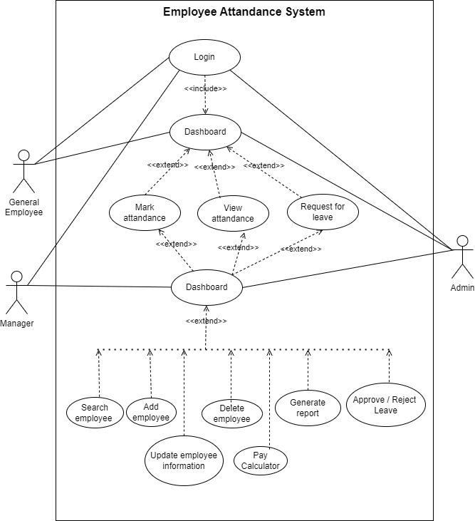

**Activity Diagram**

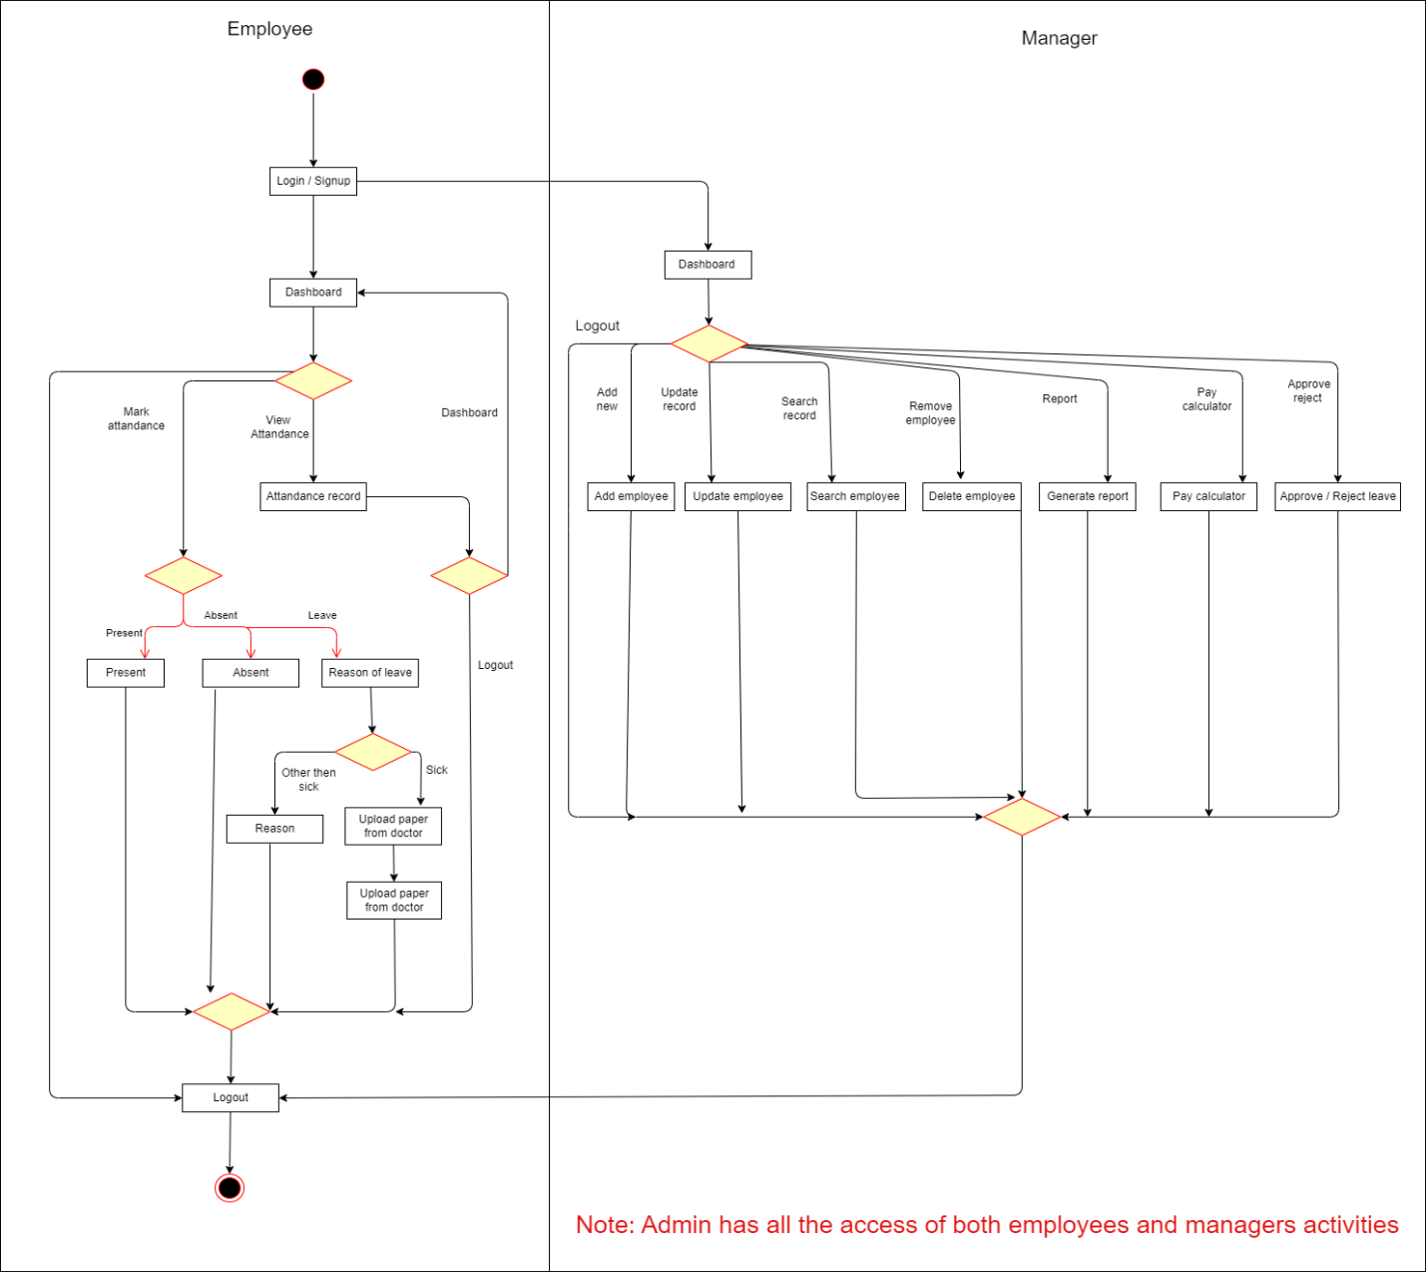

**Data flow diagram**

